Chip back potential is the level which bulk silicon is maintained by on-chip connection, or it is the level to which the chip back must be connected when specifically stated below. If no potential is given the chip back should be isolated.

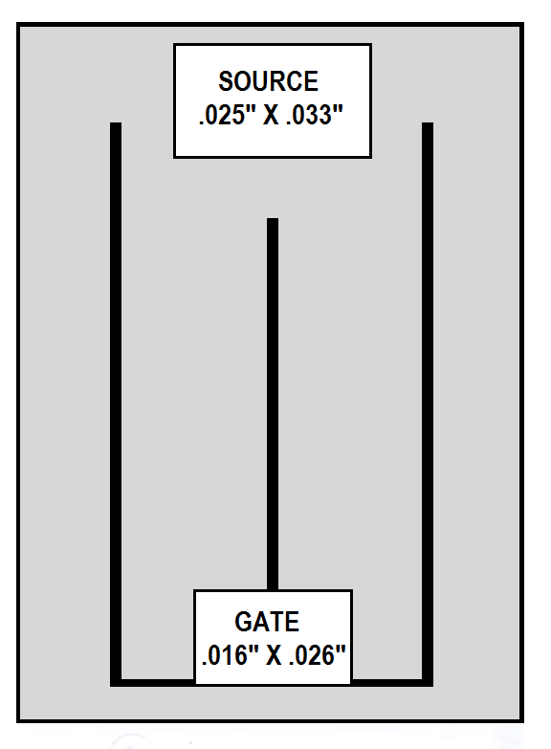
.181”
.116”

CHIP BACK IS DRAIN

Top Material: Al
Backside Material: CrNiAg
Bond Pad Size: (See Above)
Backside Potential: DRAIN
Mask Ref: HEX 3

APPROVED BY: DK DIE SIZE .116” X .181” DATE: 7/11/22
MFG: INT’L RECTIFIER THICKNESS .016” P/N: IRFC230
DG 10.1.2

Rev B, 7/19/02

